|  |
| --- |
| GENUS INNOVATION LIMITED |
| Risk Management Procedure |
|  |
|  |
| **Genus** |

|  |
| --- |
| This Procedure includes Risk Identification, Capitals, Analysis, Mitigation Planning, Mitigation Plan Implementation, and Tracking to ensure early identification and handling of risks. |

Contents

Overview 2

Objective 2

Scope 2

Inputs 2

Entry Criteria/Triggers 2

Tasks 2

Verification 5

Guidelines 5

Guidelines for identifying Risk 5

Guidelines for Risk Analysis 6

Guidelines for Risk Mitigation/Contingency Planning 7

Guidelines for Risk Tracking/Communication 8

Applicable Measurements 8

Exit Criteria/Outputs 8

# Overview

This Procedure includes Risk Identification, Capitals, Analysis, Mitigation Planning, Mitigation Plan Implementation, and Tracking to ensure early identification and handling of risks.

# Objective

* To identify potential problem before they occur so that risk handling activities can be planned and invoked as needed across the life of the product or project.
* To achieve project performance goals and objectives within defined cost, schedule, and performance constraints.

# Scope

This procedure outlines how risk management activities will be performed, recorded, and monitored throughout the lifecycle of the project.

# Inputs

* Risk Database
* Project Plan

# Entry Criteria/Triggers

* The inception of a Project
* Reassessment of the Project Risks.
* The practitioners have undergone QMS trainings with focus on performing their processes.

# Tasks

| Sr. No | Task | Owner/Role |
| --- | --- | --- |
|  | **Determine Risk Sources and Categories** |  |
|  | Identify the risk source by identifying each element of WBS and process that may cause the area of risk. There are many sources of risks, both internal , external and technological   * Uncertain Requirements * Efforts/Estimates cannot be determined * Infeasible design * Unavailable technology * Unrealistic schedule estimates or allocation * Inadequate staffing and skills * Cost or funding issues * Inadequate communication with actual or potential customers or with their representative   Refer “Suggested List of Risks” (INFO_RSKLST). | Project Manager |
|  | Determine risk categories, such as   * Customer, Safety and regulatory requirements, Inspectors, banks, unions, vendors, Government, Competitor, Skills, Budget, Resources, Components, processes, specifications, Equipments. * Risk categories help to   + Provide information about which areas of the project have the highest degree of uncertainty.   + Give further insight in the identification and analysis of risks. | Project Manager |
|  | Define the Risk parameters used to analyze risks. | Project Manager |
|  | **Risk Management Strategy** |  |
|  | Establish and document risk management strategy in the Risk Management Plan, which includes   * Sources * Categories * Risk handling options (accept, avoid, share, mitigate) * Mitigation Action Plan * Contingency Plan | Project Manager |
|  | Seek approval of Risk Management Plan by Senior Management. | Project Manager |
|  | Risk Identification |  |
|  | Refer Guidelines for Risk Identification. | Project Manager/ Functional Head |
|  | Risk Analysis |  |
|  | Refer Guidelines for Risk Analysis. | Project Manager/ Functional Head |
|  | Inform Senior Management if Risk is HIGH (48-98) through E-mail or personal meeting. | Project Manager |
|  | Risk Mitigation/Contingency Planning |  |
|  | Outline a course of action for each major risk that is to be mitigated to minimize its impact.  Refer Guidelines for Risk Mitigation / Contingency Planning. | Project Manager/ Functional Head |
|  | Risk Tracking/Communication |  |
|  | Track and monitor the level of risk on a project throughout the Project Lifecycle.  Refer Guidelines for Risk Tracking/Communication. | Project Manager |
|  | Update the Risks on regular basis using the Risk management module of GIL.ef[1].  **Use the format <Risk source>-<Risk Category>-<Risk description>**  If the Risk Priority Score changes significantly, the rationale for the same must be documented as a part of the revision history of the risk matrix. | Project Manager/ Functional Head |
|  | Analyze all Project Change Requests for their possible impact to the Project Risks. | Project Manager/ Functional Head |
|  | Risk Mitigation/Contingency Plan Implementation |  |
|  | Invoke selected risk-handling option. | Project Manager/ Functional Head |
|  | Develop the schedule for each risk handling activity. Schedule those in the Project schedule. | Project Manager |
|  | Update and inform the Process Engineering Group (PEG) to maintain the list of risks at organizational level in “Suggested List of Risks” Document (INFO_RSKLST). | Project Manager |

* Improvements/Suggestions are solicited on “Process Improvement Proposals Database”.   
*For details on the Roles and Responsibilities of the practitioners, Refer "Roles and Responsibility" document in the QMS.

# Verification

* Review and approval of Risk Management Plan by Senior Management
* Risk Matrix must be maintained by the project manager and shall be regularly reviewed in the Project Team Meetings
* Review of the process and its work products by PPQA members.
* Review of the process and its work products by Senior Management.

# Guidelines

Refer "Configuration Management and Release Procedure" (PRCD_CONFIG) for Access Rights, location of work products, naming convention and types of controls.

## Guidelines for identifying Risk

* Risk identification should be an organized, thorough approach to seek out probable or realistic risks that could prevent achieving objectives.
* Risk can be associated with all aspects of the project, and risk may be identified by any member of the team.
* The intent of risk identification is to answer the question: *What are the major uncertainties to the project and what can go wrong*?
* Risks must be identified and described in an understandable way before they can be analyzed and managed properly.
* Risks can be examined using any of the following methods:
  + Through decomposition into relevant elements or areas, such as requirements, processes, functional areas (functional analysis), technical baselines, or acquisition phases.
  + Brainstorming, Delphi technique, interviewing, root cause analysis and Strengths, Weaknesses, Opportunities and Threats (SWOT) analysis.

## Guidelines for Risk Analysis

The intent of risk analysis is to answer the question: *How big (important) is the risk,* by performing the activities listed below:

1. Evaluate risk to determine the likelihood or probability of the risk occurring
2. Categorize the risk to identify the possible consequences or impact in terms of performance, schedule, and cost
3. Determine the risk rating based on its severity/likelihood as per following criterion

I – Impact (1-5)

L – Likelihood (1-5)

PO - Prevention Opportunity (0-4)

Risk Levels: NO RISK (0-3) LOW (3-16) MODERATE (17-47) HIGH (48-98) SERIOUS - STOP (99 & Above)

The risk priority number is the product of the scores of impact, likelihood and prevention opportunity. Higher the number, higher the priority of the risk.

The risks above Risk priority score of 48 will be escalated, regularly monitored and controlled. The mitigation and contingency plans must still be created and maintained in order to be able to respond to the risks in a timely manner.

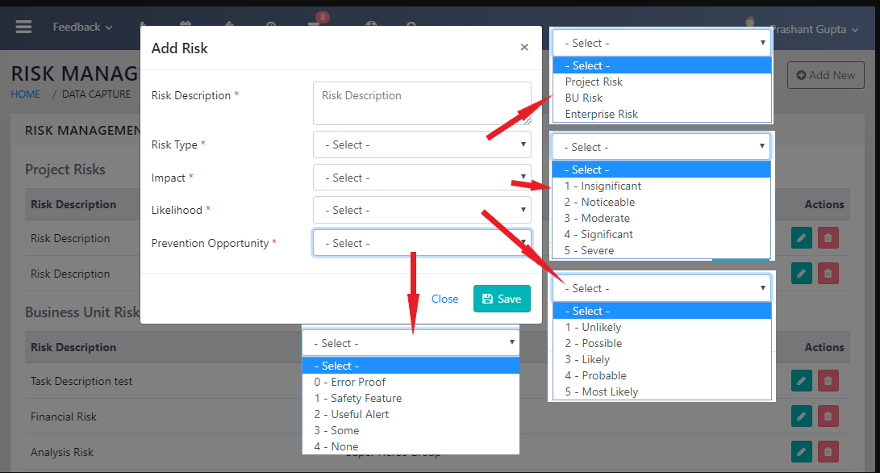

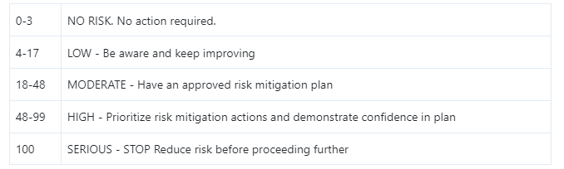

## Guidelines for Risk Mitigation/Contingency Planning

1. Definitions:
   1. Risk Mitigation: Risk Mitigation covers efforts taken to reduce either the probability or consequences of a threat. These may range from physical measures to financial measures.
   2. Contingency Plan : A Contingency plan is a plan devised for a specific situation when things go wrong
2. Risk mitigation planning is initially completed by the risk owner, and it includes the specifics of

* What should be done?
* When it should be accomplished?
* Who is responsible?
* Resources required to implement the risk mitigation plan.

1. This Plan is then sent to the Design Head for review.
2. For each root cause or risk, the type of mitigation must be determined and the details of the mitigation described.
3. A person or group will have responsibility for addressing each risk that is identified.
4. Once alternatives have been analyzed, the selected mitigation option should be incorporated into existing project plans or documented separately as a risk mitigation plan.
5. Contingency plans are developed for selected critical risks in case the impact of the risk is realized (they may include redesigning features, reallocation of resources, or others).

## Guidelines for Risk Tracking/Communication

Objective of risk tracking is to communicate risks and risk status to all affected stakeholders, including management, to establish a clear understanding and support for the project risk management strategy; to manage stakeholder expectations; and to effectively manage risks.

* Risk Tracking is the activity of systematically evaluating the status of risks.
* Risks are updated in the Risk Matrix and are tracked to closure.
* The Risk Matrix shall include
  + Risk name and description
  + Likelihood
  + Consequence
  + Priority
  + Mitigation/Contingency plans
  + Any metrics defined for tracking the risk and risk dependencies.
* The intent of risk tracking answers the question: *“How are things going?”* by performing the activities below to track risks:
  + Regularly review and re-evaluate status of all risks
  + Monitor risk mitigation and contingency efforts

# Applicable Measurements

NA

# Exit Criteria/Outputs

* Documented and updated Risks and their Mitigation and/or Contingency plans.

1. https://gil.einframe.com